CMPSC 121-Project 1
Xiangfeng Yuan
Code:
#symotion-prefix#
#################################
# Imports #
#################################
import math
import turtle

###############################################
# Function that builds the structure, ground, #
# slingshot, and draws the (X,Y) locations #
# until the projectile hit the ground or #
# structure #
###############################################
def projectile_xy(v, a, dX, dY, hs=5.0, g=9.8):
'''
calculate a list of (x, y) projectile motion data points
where:
x axis is distance (or range) in meters
y axis is height in meters
v is velocity of the projectile (meter/second)
a is the angle with repsect to ground (radians)
dX is the distance to the structure
dY is the height of the structure
hs is starting height with respect to ground (meters)
g is the gravitational pull (meters/second_square)
'''
vX_int = v*math.cos(math.radians(a))
vY_int = v*math.sin(math.radians(a))
vX_fin = vX_int
t = 0
#get all the results

#Setup the Turtle
turt = turtle.Turtle()
turt.color("blue", "red") #You can change colors here
turt.pensize(5)
#HINT: Recommend drawing the structure first,
#then ground and then slingshot

#Draw the structure
turt.lt(90)
turt.fd(dY*10)
turt.rt(90)
turt.fd(10*10)
turt.rt(90)
turt.fd(dY*10)
turt.rt(90)
turt.fd(10*10)
#Draw the ground
turt.fd(dX*10)
#Draw the slingshot
turt.rt(90)
turt.fd(5*10)
#Prep for Takeoff
turt.right(a)
turt.color("red")
turt.pensize(4)
missed = False

while True:
# Calculate the height y at time t
y =hs + vY_int*t - 0.5*g*t**2
# Check to see if projectile has hit ground level
# if projectile hit the ground, use the break command
# to exit the loop
if y < 0:
break

# Calculate the distance x at time t
x = vX_int*t
# Check if the projectile has hit the structure
# Hint: check for the following:
# missed is False and x value is >= distance x and y is > 0
if x >= dX and y > 0:
if y < dY:
break
elif x > (dX + 10):
missed = True
# Move the Turtle to the (X, Y) position
turt.goto((x-dX)*10,y*10)
# Use the time in increments of 0.1 seconds
t += 0.1

##############################
# Main Program #
##############################
#Insert the code from Task 1 of the program here
import math

v = int(input("The magnitude of the velocity of the Red Bird in m/s:"))
a = int(input("The angle with respect to the horizontal of the velocity vector, in degrees:"))
d = int(input("The horizontal distance to the structure you're trying to knock down with the Red Bird, in m: "))
h = int(input('The height of the structure in m:' ))

vX = v*math.cos(a/180*math.pi)
vY = v*math.sin(a/180*math.pi)
g = 9.8
#defines some of the numbers.

t = d/vX
#t is the time that bird needs to reach the building.
tt = (d+10)/vX

tDec = vY/g
#tdec is the time that the bird fly up.

hhit = 5+vY*t-0.5*g*t**2
h2hit = 5+vY*tt-0.5*g*tt**2
#hhit is the height when the bird (maybe) touches the building.

vF = math.sqrt(vX**2 + (g*(t-tDec))**2)
rad = math.atan((g*(t-tDec))/vX)
arc = rad/math.pi*180
#vF is the final velocity of the bird. arc is the angular of the speed.

print('\nthe bird is travelling at a speed of ' + str(vF) + ' meters per second.\n')
print('and the speed is at an angle of ' + str(arc) + ' degrees below the horizontal.\n')

if hhit > 0 and hhit < h:
print("the bird reaches the building in " + str(t) + ' seconds.\n' )
print("the bird is at a height of " + str(hhit) + " when it reaches the building.\n" )
print("so it hits the building.\n")
elif hhit > 0 and hhit > h:
print("the bird is at a height of " + str(hhit) + " when it reaches the building.\n" )
if h2hit <= h:
print('so it still hits the building.')
else:
print("so it flies over the building.\n")
elif hhit < 0:
print("the bird stops before it reaches the building.\n" )
print("so it won't hit the building.\n")

# Set up the window and its attributes
wn = turtle.Screen()
wn.bgcolor("white")

#########################################
# Following line calls the function for #
# drawing the results #
# Variables used for parameters: #
# v = Input velocity #
# a = Gravity #
# d = Distance in X direction #
# h = Height of the structure #
#########################################
projectile_xy(v, a, d, h)

# Runs the graphics until they are closed
wn.mainloop()

Example run1:
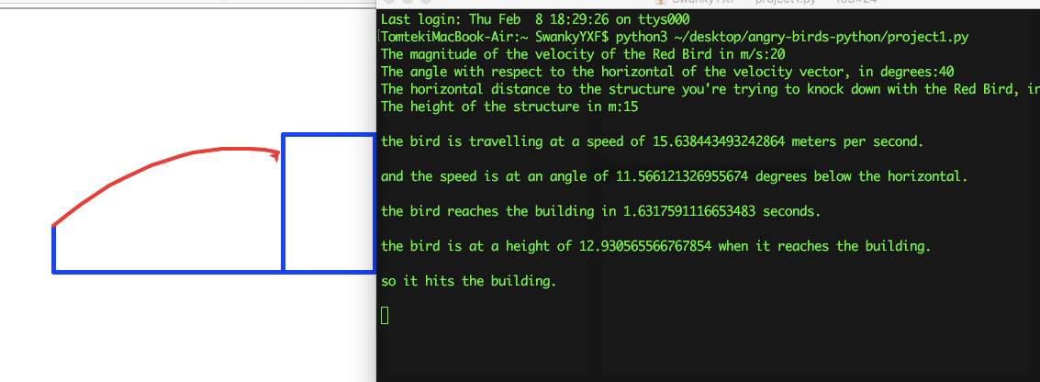
20 40 25 15

Example run 2:
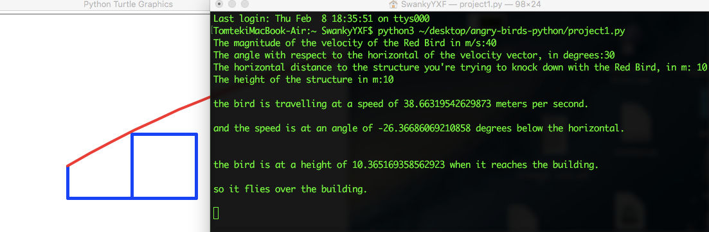
40 30 10 10

Example run 3:
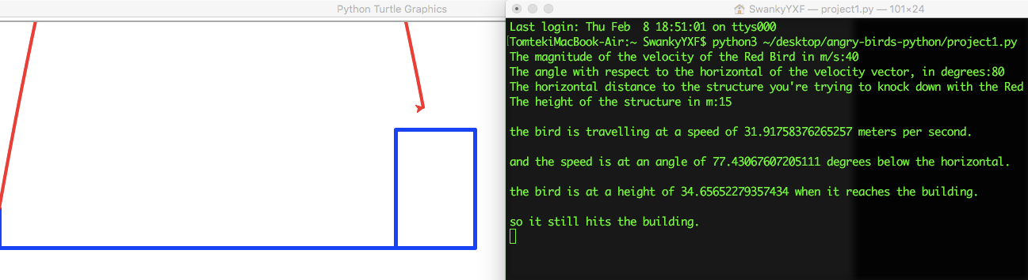
40 80 50 15

